**AIM:**

To implement **Breadth-First Search (BFS)** traversal of a graph using an adjacency matrix.

**📘 BFS Algorithm Overview:**

1. Start from a **source node**, mark it as **visited**, and enqueue it.
2. While the queue is not empty:
   * Dequeue a node.
   * Visit all its **unvisited adjacent nodes**.
   * Mark them visited and enqueue them.

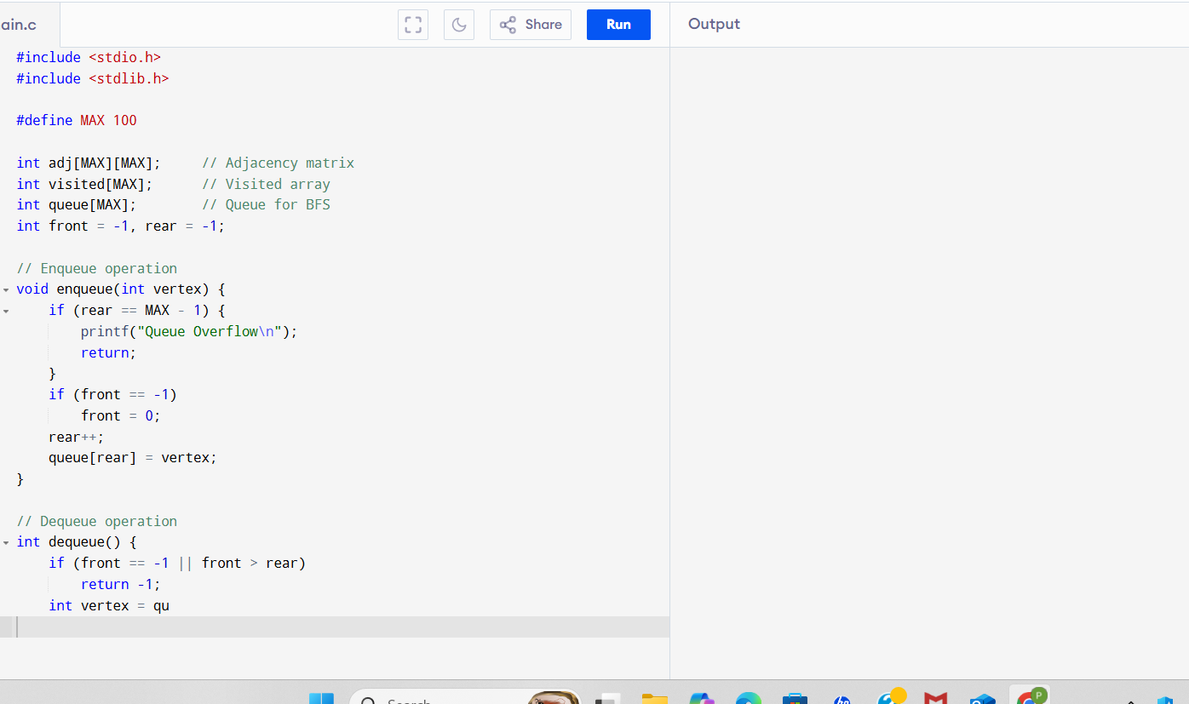

**SAMPLE OUTPUT:**

Enter number of vertices: 6

Enter number of edges: 7

Enter 7 edges (format: u v for an edge between u and v):

0 1

0 2

1 3

1 4

2 4

3 5

4 5

Enter the starting vertex for BFS: 0

BFS Traversal starting from vertex 0:

0 1 2 3 4 5